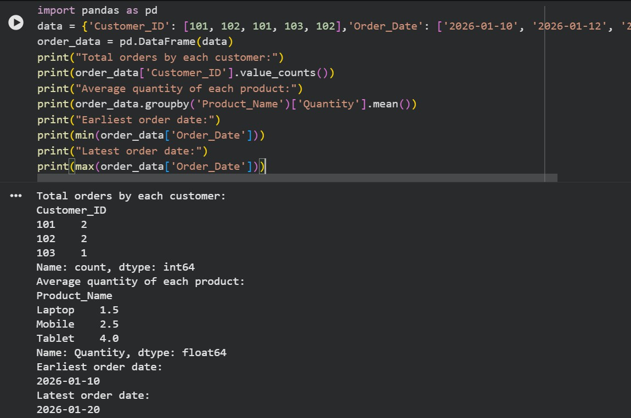
- Scenario: You are working as a data analyst for an e-commerce company. You have been given a dataset containing information about customer orders, stored in a Pandas DataFrame named order_data. The DataFrame has columns for customer ID, order date, product name, and order quantity. Your task is to analyze the data and answer specific questions about the orders. Question: Using Pandas DataFrame operations, how would you find the following information from the order_data DataFrame: 1. The total number of orders made by each customer.2. The average order quantity for each product. 3.The earliest and latest order dates in the dataset.
- Scenario: You are a data scientist working for a company that sells products online. You have been tasked with analyzing the sales data for the past month. The data is stored in a Pandas dataframe.Question: How would you find the top 5 products that have been sold the most in the past month?

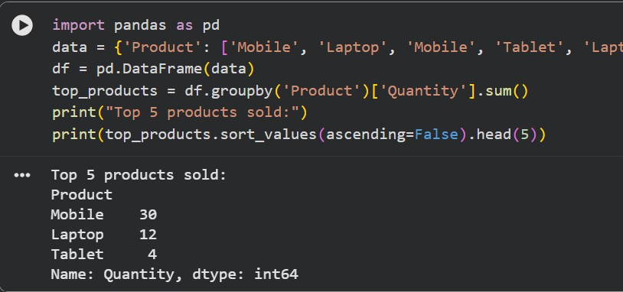
- Scenario: You work for a real estate agency and have been given a dataset containing information about properties for sale. The dataset is stored in a Pandas DataFrame named property_data. The DataFrame has columns for property ID, location, number of bedrooms, area in square feet, and listing price. Your task is to analyze the data and answer specific questions about the properties. Question: Using Pandas DataFrame operations, how would you find the following information from the property_data DataFrame:1. The average listing price of properties in each location. 2. The number of properties with more than four bedrooms.
3. The property with the largest area.
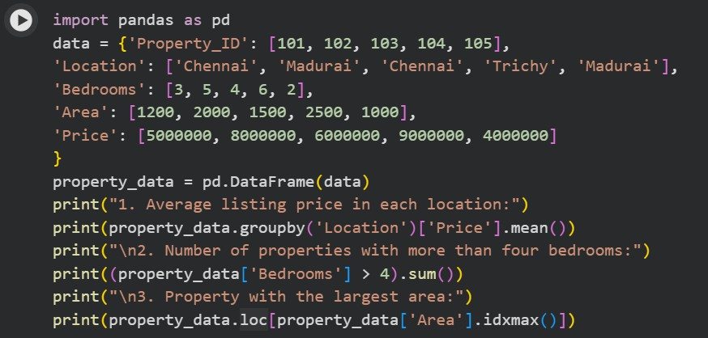

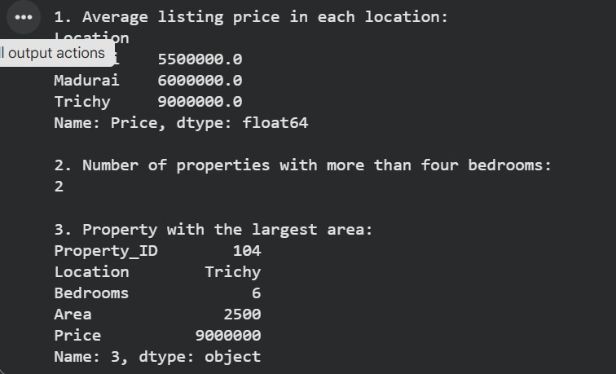
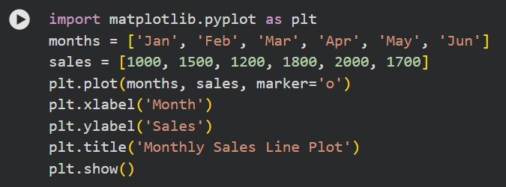
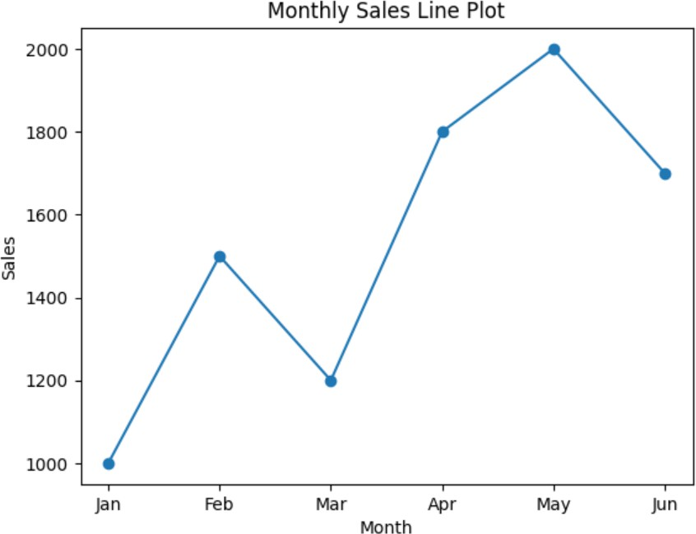
- Scenario: You are working on a data visualization project and need to create basic plots using Matplotlib. You have a dataset containing the monthly sales data for a company, including the month and corresponding sales values. Your task is to develop a Python program that generates line plots and bar plots to visualize the sales data.Question:1. How would you develop a Python program to create a line plot of the monthly sales data? 2: How would you develop a Python program to create a bar plot of the monthly sales data?

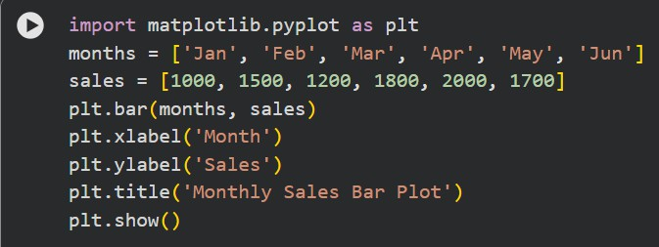
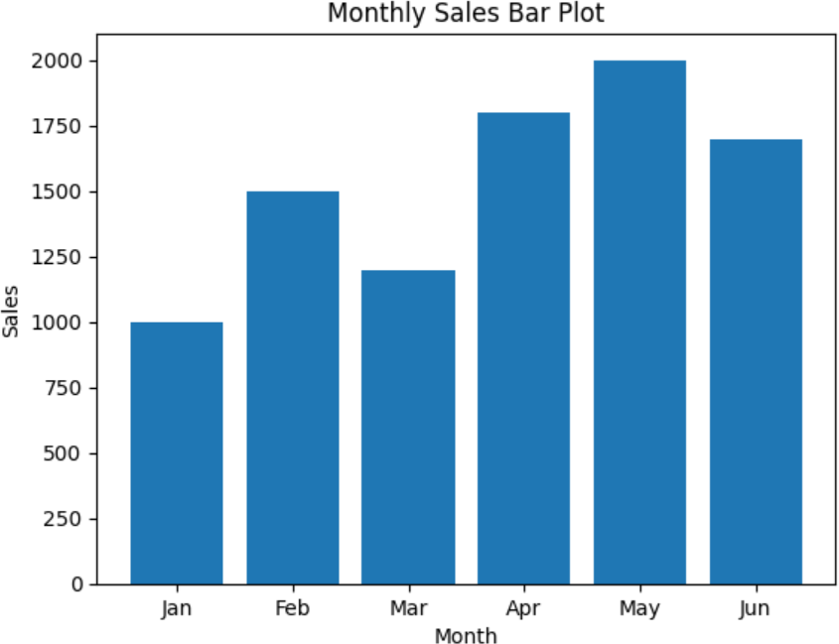
- Scenario : You are a data scientist working for a company that sells products online. You have been tasked with creating a simple plot to show the sales of a product over time. Question:
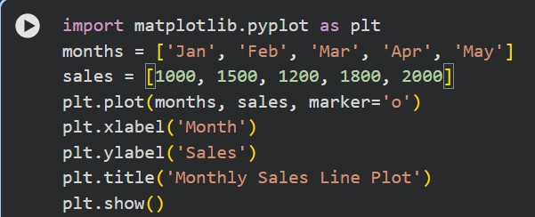
1. Write code to create a simple line plot in Python using Matplotlib to predict sales happened in a month? 2. Write code to create a scatter plot in Python using Matplotlib to predict sales happened in a month? 3. Develop a Python program to create a bar plot of the monthly sales data.

